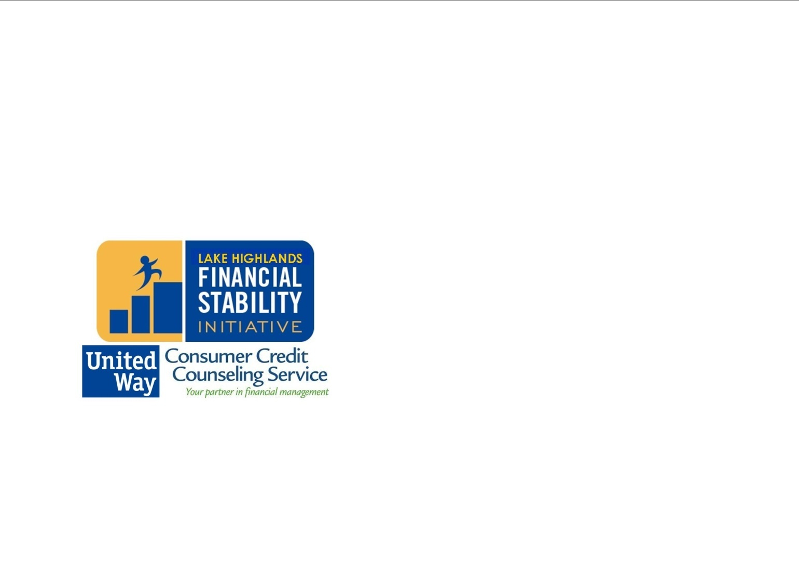

**Lake Highlands**

**Financial Stability Initiative:**

Financial Counseling and Education

Get Started Today! Call 214-540-6837

Free Financial Literacy Education and Counseling

www.cccs.net

**Please attend an upcoming free class:**

Episcopal Church of the Ascension: Sun. Jan. 12th, 1:30pm

Arms of Hope: Tues. Jan. 14th, 11am

Hidden Ridge Apartments: Tues. Jan. 14th, 2:00pm

The New Room (Skillman crossing): Sat. Jan. 19th, 12:30pm

**Schedule free personal financial counseling on Tuesdays - Thursdays in Lake Highlands. Call 214-540-6837!**

Tuesdays

10am – 2pm, Arms of Hope at Highland Oaks Church of Christ (Walnut Hill & 635)

Wednesdays

9am – 5pm, Healing Hands Ministries (Royal & Greenville)

Thursdays

9am – 5pm , The New Room (Skillman Crossing: Whitehurst & Audelia)

Call 214-540-6837 to schedule

**Let us help you learn how to get Financially stable!**

•12-Month Program

•Free Counseling

•Free Education

•Free Credit Report

•Reduce Debt

•Increase Credit Score

•Build Savings with Matched Savings Accounts

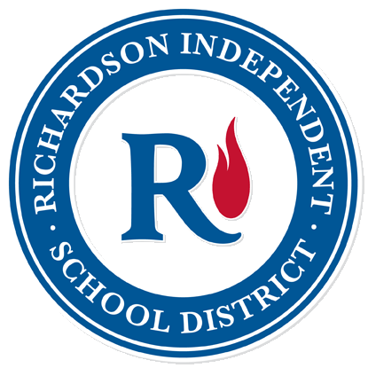

Community Partner

**Financial Stability can be defined within three simple goals:**

1. **Reduce Debt** – Create a plan to reduce your debt load by 20% and create more spending power. This is a critical step to freeing your financial future.
2. **Increase Credit Score** – Learn how to increase your score 25 points or more throughout the program.

**3. Save for Emergencies** – Be prepared for the unexpected with at least three months of basic living expenses. Earn a dollar for every dollar you save with our matched savings program (up to $25 per month)!